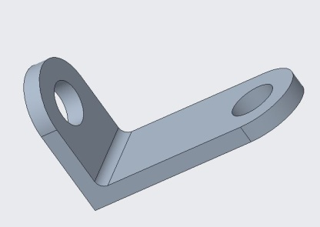**EXPERIMENT NO.1**

**AIM:** To prepare a Bracket model and draw its views

**LEARNING OBJECTIVES:**

♦ Create 2-D Sketches

♦ Create Simple Extruded Solid Models

♦ Understand the Basic Parametric Modelling Process

♦ Understand the "Shape before Size" approach

♦ Use the Dynamic Viewing commands

♦ Create and Modify Parametric Dimensions

♦ Draw the orthographic views of the models and dimensioning

♦ Create Tables and saving in .pdf format

**TOOLS REQUIRED:**

Creo Parametric 5.0 software

**SEQUENCE OF OPERATIONS:**

1. Sketch, 2. Extrude, 3. Round, 4.Drawing of Views and Table

**PROCEDURE:**

1. Select part model and solid modelling and give the name of the part model
2. Select Top plane and go to sketch module
3. Select perpendicular view of the plane select from dynamic tool bar show in the picture.
4. Select rectangle tool to draw from sketch tool bar
5. Draw a rectangle of any dimensions
6. Now to assign dimensions select dimension tool from sketch tool bar and assign given dimensions to the rectangle
7. Select circle tools from sketch tool bar. Draw a circle from midpoint of 50mm edge to the next corner of ∅50mm
8. Select delete segment tool from sketch toolbar and trim unnecessary edges and curves as show in picture by dragging towards the semicircle and one edge of rectangle
9. Next, draw another circle of ∅25mm from centre of the ∅50mm circle as shown
10. Now exit the sketch module and click extrude tool from model toolbar
11. Add a thickness of 10mm and click ok in extrude toolbar
12. Now select right plane and select sketch module again
13. Again click perpendicular view icon from dynamic toolbar in model window as shown in below picture
14. Now follow the same procedure used to model the base and complete the sketch
15. Once you done with sketch module go to extrude module and give thickness of 10mm and click ok. Now select the corner as shown in below picture and select round tool in model toolbar to give fillet
16. Add fillet radius of 5mm and click ok.
17. Now go to file option, click save as and select target folder to save
18. Save it in prescribed format and click ok to complete the exercise
19. Select New option from File Table and click on Drawing module
20. Select a4_sheet option from Template window and click on OK button
21. Now the 3 views are created in Third angle projection and to be changed to First angle projection by using “Lock view movement” from Lay out tab
22. Dimension the views by clicking on “Show Model Annotations” from Annotation Tab. Select the view and click on Show Model Annotations. Continue to add dimensions to other views by pressing Ctrl button
23. Add the view names by selecting “Note” from Annotations
24. Create a Table with 2 Columns and 7 Rows to add details like Experiment No., Place, Course Name, Course Code, Name, Register No., Section No.
25. Save in PDF format to take the print out

**PRECAUTIONS:**

1. Initial settings like Model Display, Sketcher and Working directory are to be completed before modelling
2. Save the Part model and drawings with .prt and .drw formats respectively

**RESULTS:** Required Bracket is modelled and drawn its views